Zachery Francis
CISC 3140
3/3/2026
Brooklyn College

Homework 3

https://github.com/Marqed4/Time-Rabbit
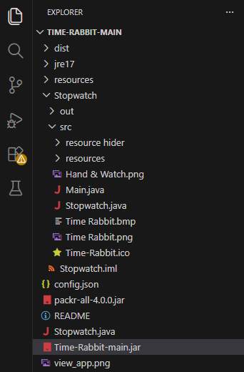

Turning into a .jar file
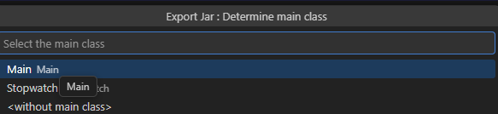
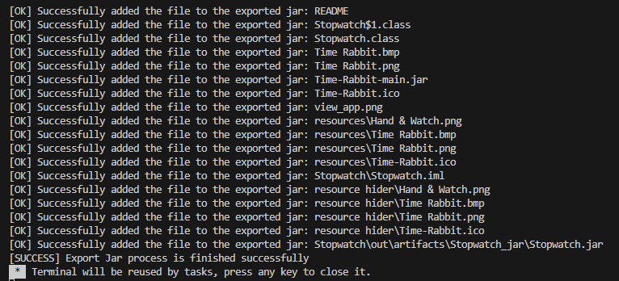

After Creating .jar file
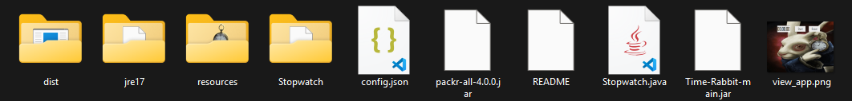

cd C:\Users\Derpe\Desktop\Time-Rabbit-main
java -jar Time-Rabbit-main.jar
